Module 3: IAM Users Assignment

Problem Statement:
You work for XYZ Corporation. To maintain the security of the AWS account and the resources you have been asked to implement a solution that can help easily recognize and monitor the different users.
Tasks To Be Performed:
1. Create 4 IAM users named “Dev1”, “Dev2”, “Test1”, and “Test2”.
2. Create 2 groups named “Dev Team” and “Ops Team”.
3. Add Dev1 and Dev2 to the Dev Team.
4. Add Dev1, Test1 and Test2 to the Ops Team
Steps:
1. Create 4 IAM users named “Dev1”, “Dev2”, “Test1”, and “Test2”.

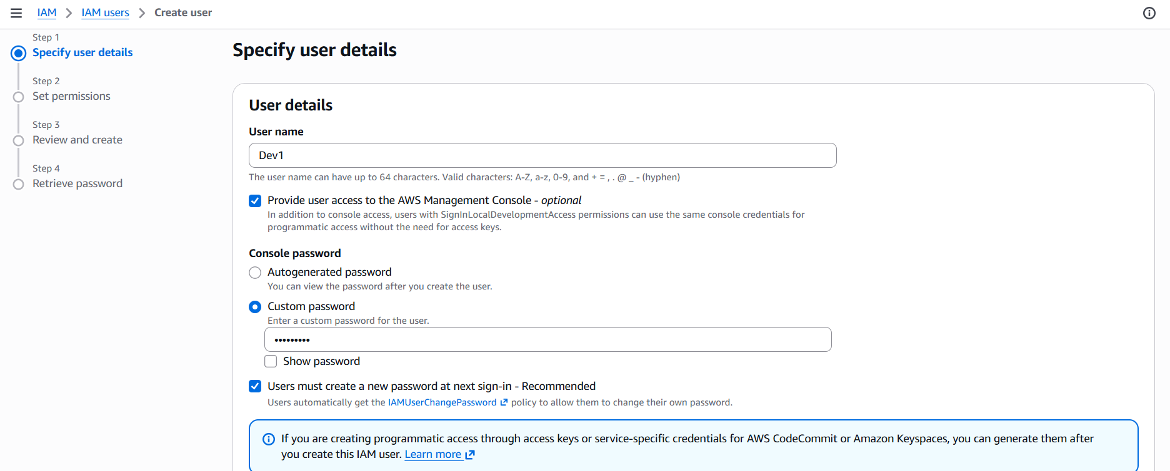
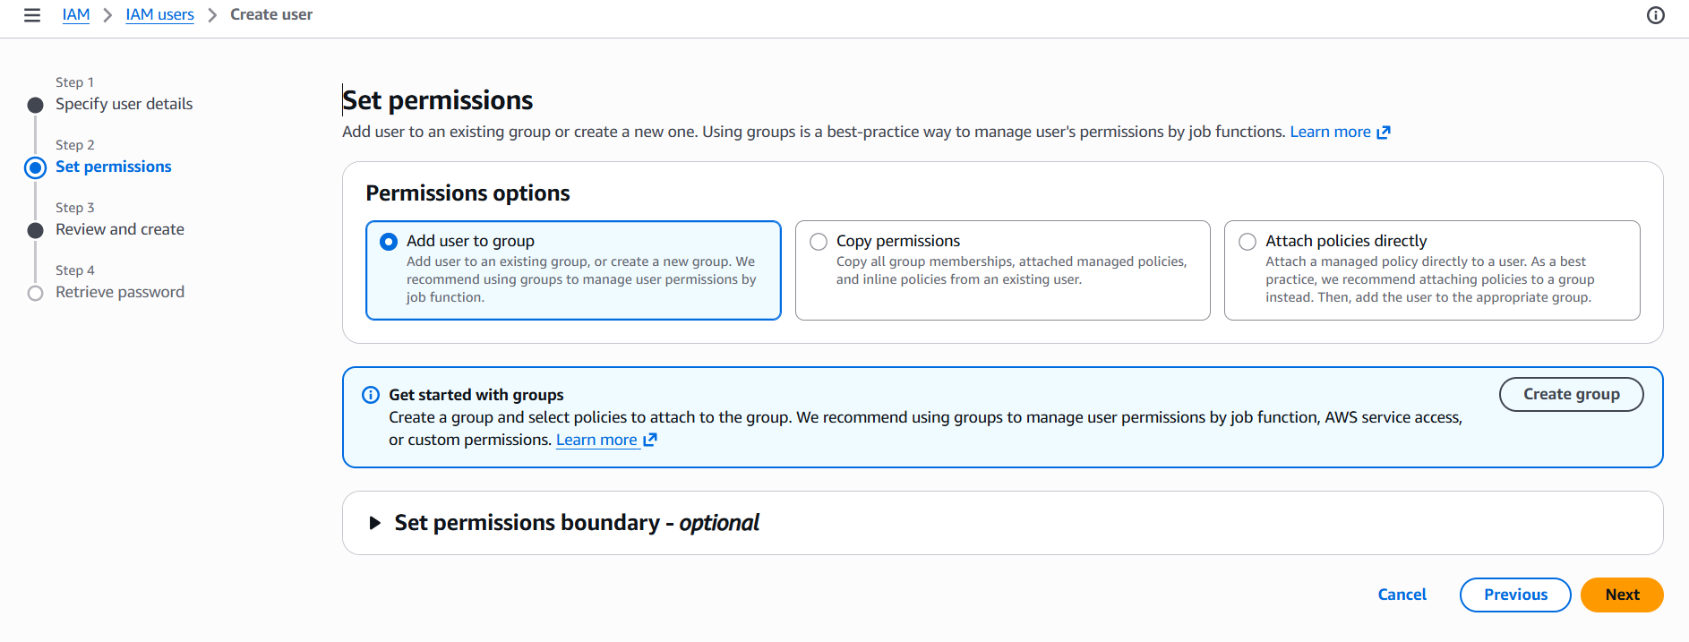

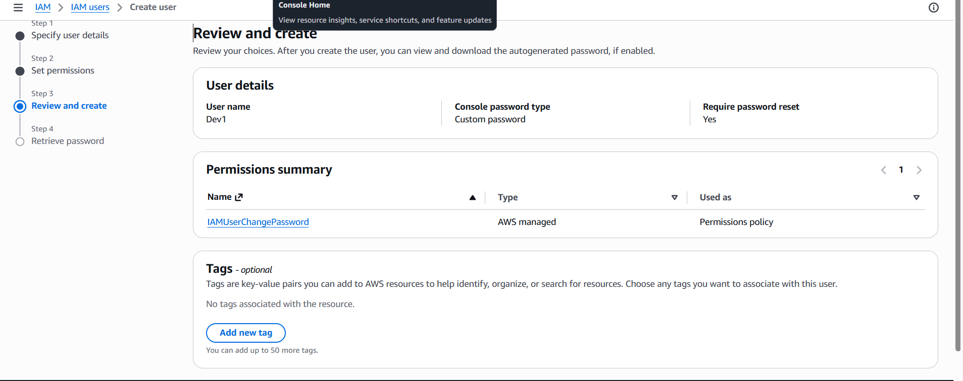

Create & download the .csv file:
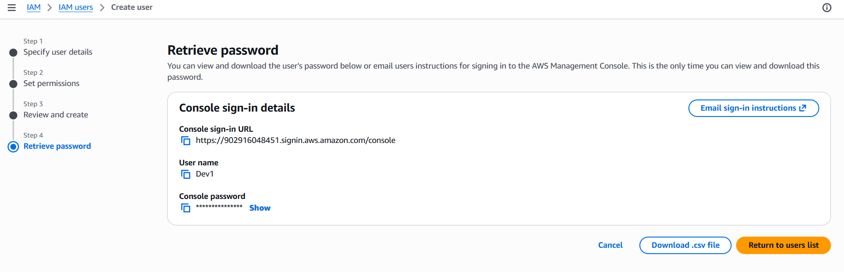

All four users are created:
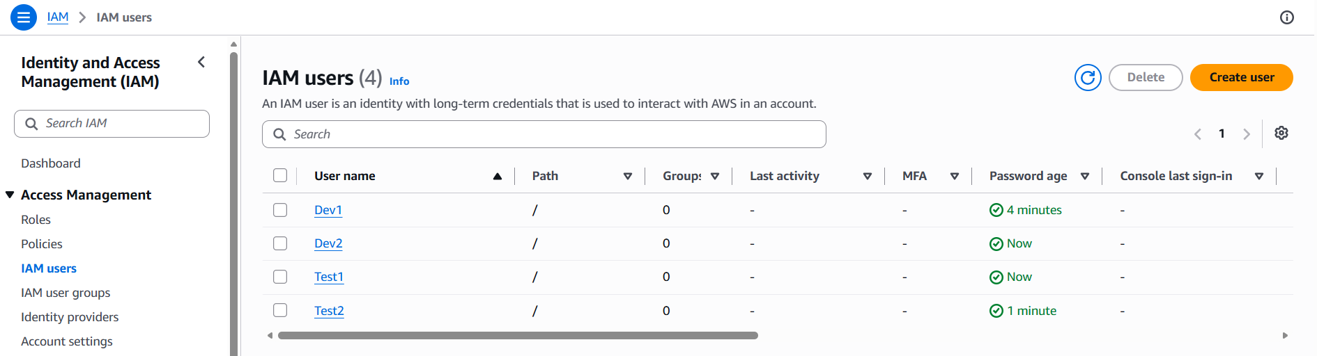

2.Creating Group DevTeam and add dev users:
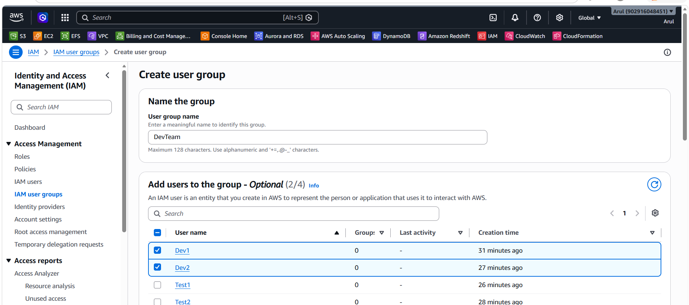

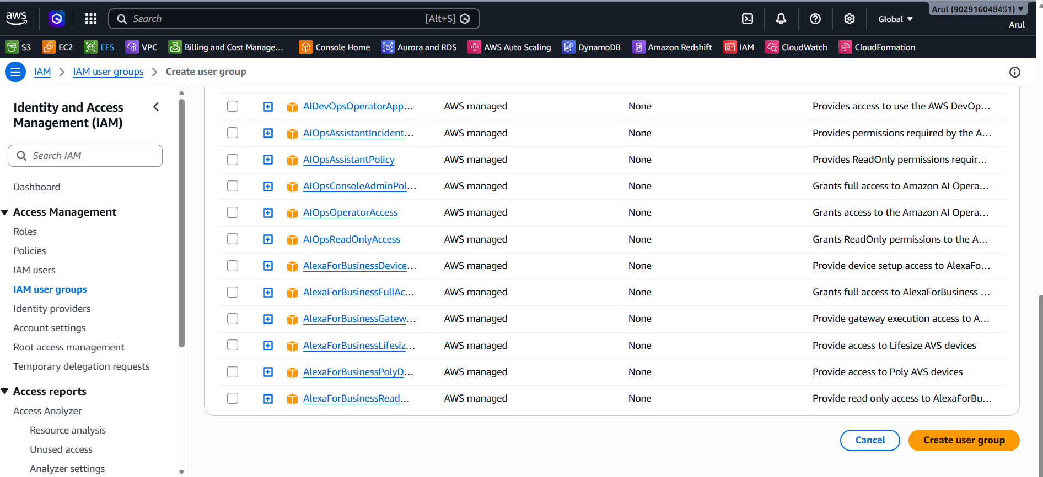

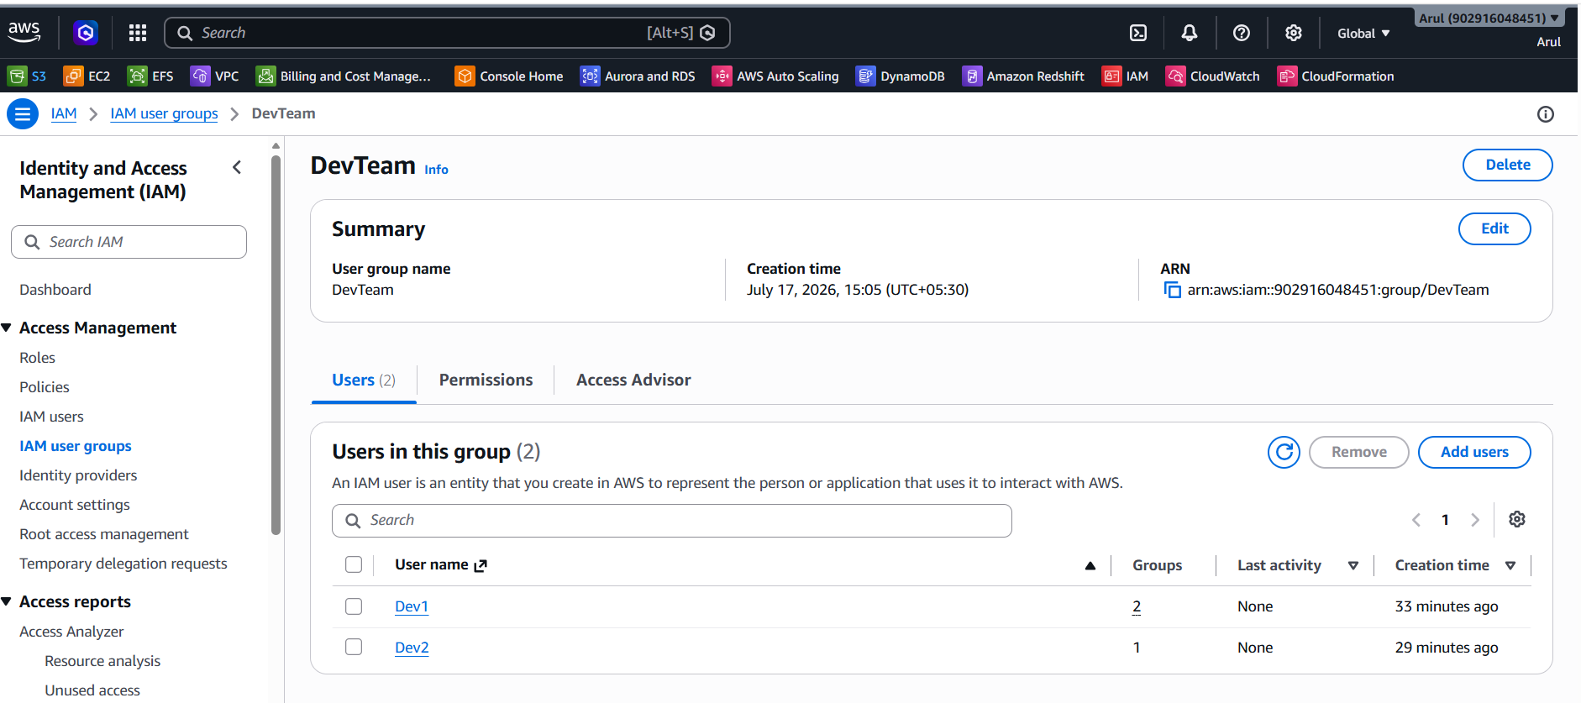

Creating OpsTeam group and adding users: Dev1, Test1, Test2
